**The Tolland Man mystery**

Background:

The body of ‘Tolland Man’ was found in a peat bog on Tolland Fen in Denmark in May 1950. Two men were digging peat for burning. As they worked they suddenly saw in the peat layer a face so fresh they thought they had come across a recent murder.

The men carefully removed the peat from the body until more of him could be seen. The man lay on his right side as if he was asleep. He wore no clothes, except for a pointed animal skin cap and a smooth leather belt. His hair was cut sort. Round his neck was a rope noose and an iron neck ring. It was drawn tight around his neck and throat. They called the police.

Study the sources below help to piece together the mystery of the Tolland Man.

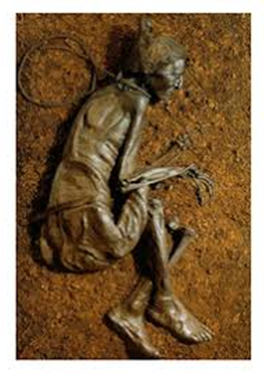

**Source A**: a photograph of the Tolland Man, taken in May 1950.

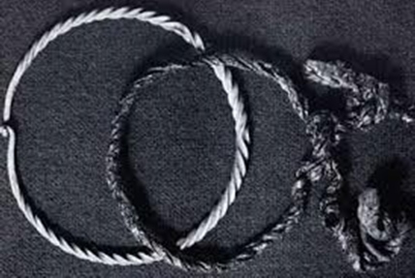 **Source B**: a photograph of an iron ring and rope noose similar to those found around the neck of Tolland Man.

**Source C:** an extract from the scientific report written about the Tolland Man, written in the 1950s.

|  |
| --- |
| **Age:** The heart and the other organs were healthy. The wisdom teeth had grown. Wisdom teeth appear in people around 20 years old.  **The Stomach:** The man had eaten soup at least 12 hours before he died. The soup was made up of seeds that were connected only with the Spring.  **Date of burial:** When they dug the grave, some plants had got trapped under the body. These types of plants are about 2,000 years old. |

**Source D:** an extract from a book about Germanic Tribes, written around 98AD. German tribes once lived in Denmark.

|  |
| --- |
| The German tribes worship the Goddess of Spring. Every Spring a cart carries a statue of the Goddess in a procession. Afterwards the cart and the statue are washed by slaves. Then the slaves are sacrificed. |

**Source E:** an image of the German Goddess of Spring.

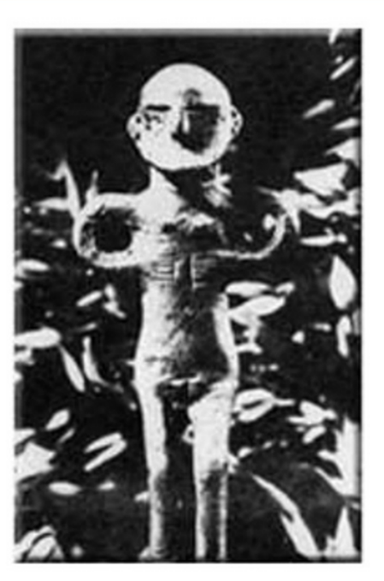

**Source F:** an extract from a book about Germanic Tribes, written around 98AD.

|  |
| --- |
| The German tribes hang traitors from trees and drown cowards in fens under piles of sticks. |